

PRJ DOCUMENT

**Software Requirements**

Introduction

The DEPDEVS Protocol to police administration

# Purpose

This purpose of this software requirements for the Police department is to reach a level of detail including case numbers, case papers, dockets, case files which are circulated amongst the administration and the stakeholders, in particular the victims of lost case files, it is also intended to serve as a basis for justice in south Africa during which elements for a high-level case documents will be gathered to come in conclusion depending on the faced case being reviewed in the justice system, this software requirements is to clarify, validate an verify requirements for the police department as expressed by the DEEPDEVS focusing on its function aspects of helping the department to work efficiently and under regulation of safe protocols, we focusing on capturing and describing the desired behavior of the end product in a wide range of situation in the criminology case files.

This document is also intended to be a planning instrument for the development of the application specified above and its potential derivatives.

# Scope of the project

As described in the above purpose justification, this application is a tool to facilitate discovery and access to data files at a national and regional level of justification in the department of police, including the possibility to offer access to additional sources of information on the case being investigated, our primary users are surveillants and the front end task forces working on case files on the daily basis, the data taken on the cases must be provided to the community to create a whole sphere of influence which by that we derive an understanding of what cases are needed to be looked and which have to be looked at.

This software tool features the technical part, which DEEPDEVS envisioned as an important public relations and communication tool for the community.

# Document conventions

The main type of convention used throughout this document helps represent level of priority of the different software requirements, this way we are able to prioritize the requirements which are suppose to be looked at with constant support and attention.

## Actor Survey

* This section lists the different actors DEEPDEVS instances we shall interact with, listed as : End users (primary actors) and actors from which the system needs assistance to satisfy a goal (Secondary actors).

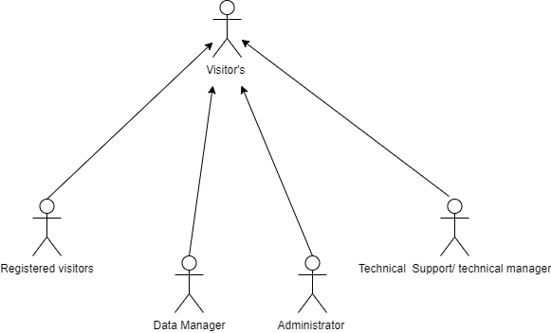

Figure 1 primary Actors

Front End users

1. Visitors : They only have access to the system frontend and can place complaints plus check progress
2. Registered visitors: Once registered, a visitor is offered extra functionalities to save and load Documents or save files, this includes the front-end task force.

Back-office users

1. Administrator: They are responsible for installing, configuring and monitoring the system and managing the case files, they are also in charge of managing user accounts and associated roles they should have skills in system administration, database management and deployment of Web applications.
2. Data Managers : in charge of maintaining the software resources
3. Support : they configure the according to profiles and cases and provide updates.

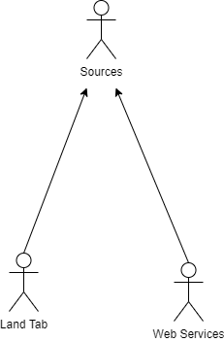

Figure 2 Secondary Actors

1. Sources : Case files
2. Land tab : Case file holder
3. Web Services : Case reports and progress on case files.

# Use case model Survey for Admin, user and registered user

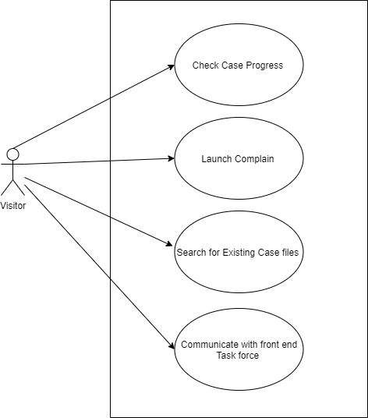

Figure 3 Visitor Use Cases

|  |  |
| --- | --- |
| Description | The Visitors Cases Are   * Check cases progress on reported cases * Complaints * Search for existing files, for referral purposes * Communicate with the front-end police task force or any reports launched |

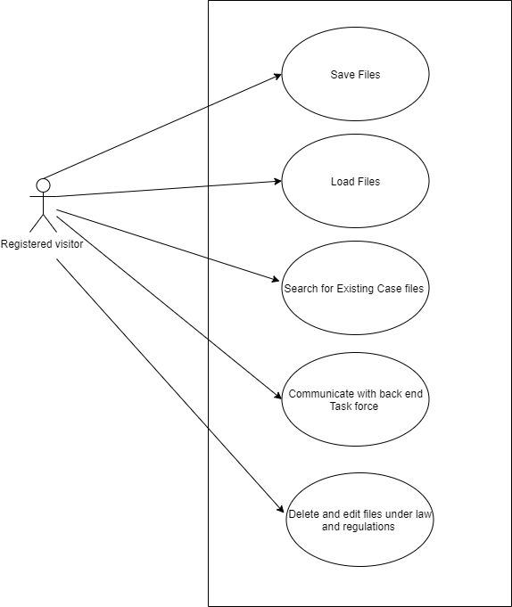

Figure 4 Registered user or visitor cases

|  |  |
| --- | --- |
| Description |  |

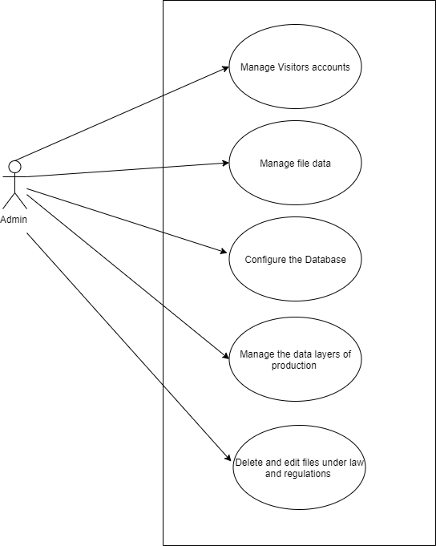

Figure 5 Administrator

|  |  |
| --- | --- |
| Description |  |

## Functional and Non-Functional requirements of the software

|  |  |  |  |
| --- | --- | --- | --- |
| FUNCTIONAL REQUIREMENTS | | |  |
| 1. INTERACTION | 1. USER DATA AND CONTROL | c. INSTRCUTIONS | D. EXTENDED FUCNTIONS |
| * Data scenes with represented models and file caption dates | * User instructions and controls | * Question interface for usage | * Screen and video capture |
| * Interact with task force | * Buttons and functional keys | * Instruction displays for usage | * VOIP usage onsite for authentication |
| * Interactive navigation format | * Responses related to data capture | * Chat bot |  |
| * Tab control |  |  |  |

|  |  |  |  |
| --- | --- | --- | --- |
| Non functional | | | |
| 1. Usability requirements | 1. Technical requirements | 1. Efficiency requirements | 1. Development requirements |
| * Be able to use the provided Tab equipment | * Accessibility | * Performance | * Software Costs |
| * Know how to operate a simple touch on request navigation | * Interoperability | * Availability of capacity | * Labor intensity |
|  | * Scalability |  | * Documentation |
|  | * Extensibility |  |  |